# Purpose

The district instance of eLumen provides the following:

* Public-facing publication
  + Course outlines of record (CORs)
  + Program outlines of record (PORs)
* District-wide vetting and review per AP 4022/4023
* Alignment of district-wide shared fields between college instances
* Electronic transmission of curriculum data to the student information system

# Library (public-facing, without login)

The landing page, accessible to the public without logging in, displays the “Library,” a list of courses and programs that have completed their workflow sequence. For courses, the list shows the course identifier, title, college, effective term of the current version, and the date upon which it was approved. By clicking the arrow to the right of each listing, additional information is available: the author and the district approval date (when it was submitted from the college instance or completed the notice period or DCC review). There is also a button to click to view the outline.

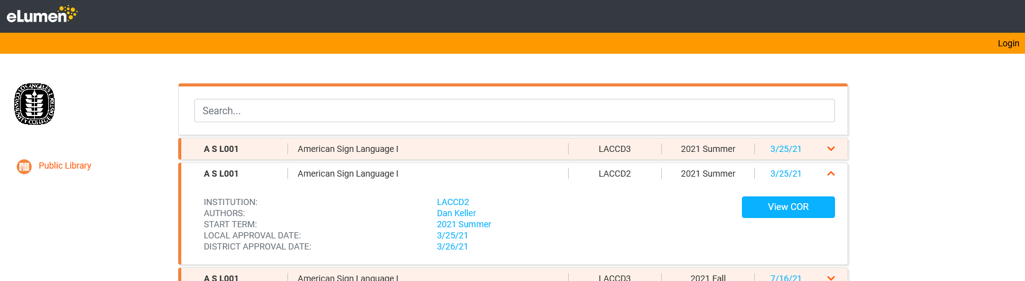

# Course Outline of Record (COR) (public-facing)

The version of the COR displayed on the public-facing Library includes only the minimum fields required by regulation, plus a few additional ones typically needed by potential articulating institutions and other agencies. (See the COR template in Appendix A of this document.)

Note: Use this public form of the COR for all external purposes (submission to COCI, Assist, articulating institutions, C-ID, and providing to students or other members of the public, etc.). Please do not use the version of the COR available when logged into a college instance. Though both versions are completely aligned, the college instance version includes many more fields than are necessary for public consumption and is extremely long and difficult to navigate. Using that version could result in outside organizations missing important details or using inappropriate criteria when evaluating outlines.

# LACCD Standard User Screens (when logged in)

To login to the district instance, click the link in the upper right corner of the page. This will redirect to the single sign-on (SSO) page where you can enter your LACCD username and password. Then you will be re-directed back to eLumen. Depending on your role in the district instance, the site will have slightly different features. For standard users (college users who are not members of DCC), the options on the left will include the “Dashboard” and the “Library.” (The “Configuration” option shown below will only be available to administrative users and will be describe later in this document.)

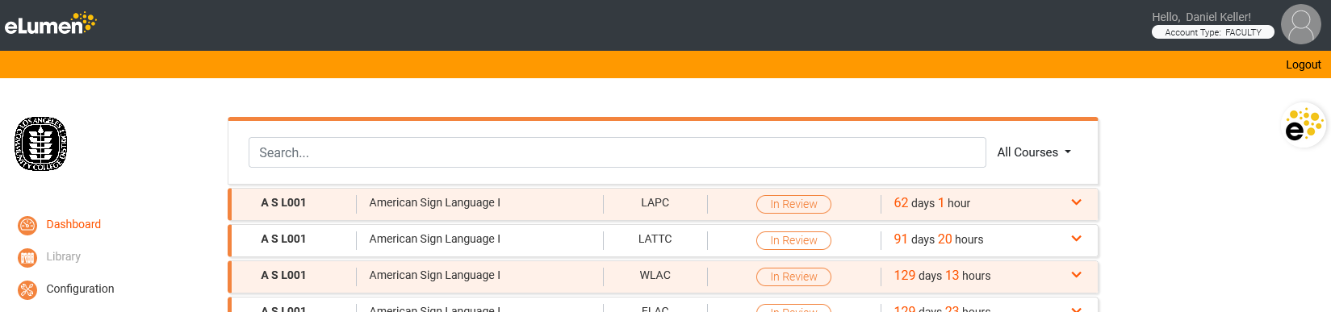

# Dashboard

The Dashboard displays all workflows that have completed the college approval sequence and that require district vetting (aka, “sunlighting”). Workflows will be displayed in the Dashboard for the required number of days (see AP 4022/4023). The sunlighting clock will start the moment the workflow enters the Dashboard. The remaining number of days and hours will be displayed next to the workflow. By default, workflows in the Dashboard will display as “In Review.” However, any workflow that has been “flagged” for DCC action by a college Curriculum Committee Chair will display as such. Upon completion of the sunlighting period, any workflow that has not been flagged will move to the “Library” and will no longer be displayed in the Dashboard.

Note: The Dashboard will henceforth take the place of district-wide posting emails. Since the Dashboard will be an ongoing posting, relevant users (Curriculum Committee Chairs, Senate Officers, Department Chairs, discipline faculty, etc.) are encouraged to visit the Dashboard regularly to view what is being proposed—perhaps once per week during faculty duty days (fall through spring). This will enable them to notify colleagues when a proposed change might pertain to their discipline.

When users wish to see the details of a workflow, for example the COR, they may click the down arrow to the right of the workflow listing. It will then expand to show additional information such as the date and time the workflow will have completed sunlighting, the proposal rationale, and a button to click to view the outline.

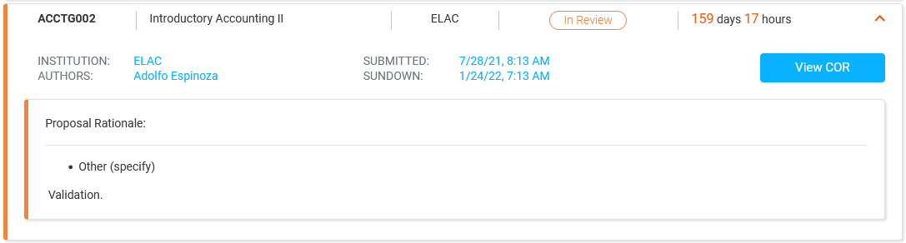

When the “View COR” button is clicked, the default view will show the outline detail.

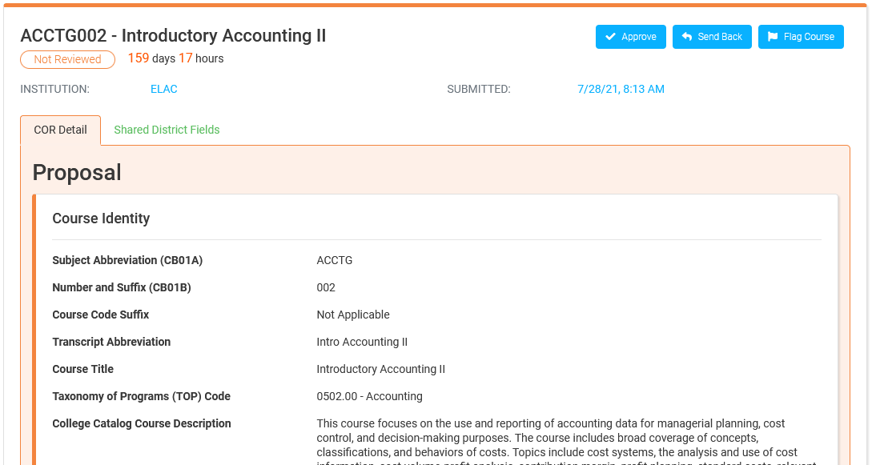

Next to this, the “Shared District Fields” tab will display a comparison between the previous (or current) values and the proposed values for those fields. Note: For new courses, the “Previous Values” column will display “No Value” for each field.

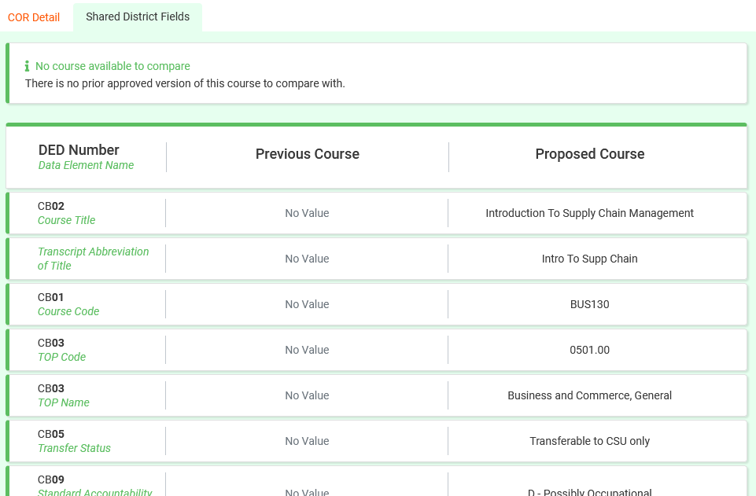

# Library (while logged in)

While logged in, the Library will behave the same way as it does in the public view (when not logged in), with one exception. When you view the COR you will see a “Copy Course” button in the upper right.

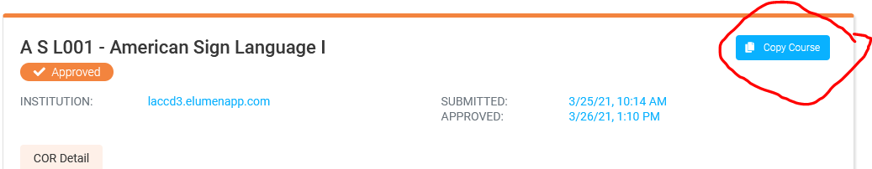

This feature enables you to adopt a course from another college or to use an existing course at any college as the basis for a similar (but new) course. Clicking this button will open the following window where you can specify to which college you want the original copied and whether you intend to adopt it (maintaining the same subject and number) or adapt it (into a new course with a new subject and number). Note: The following image is from a test site. Where you see “LACCD1, 2, and 3” under “Copy to,” you would normally see a list of the nine colleges.

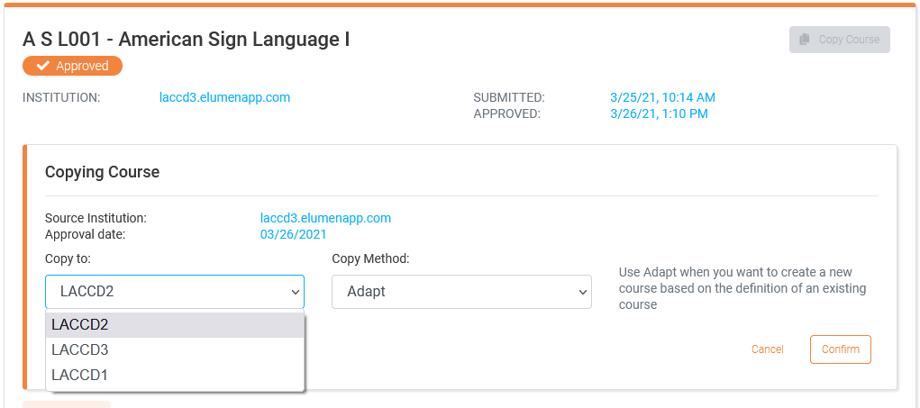

The “Copy Method:” drop-down is where you choose whether to adapt the course or adopt it.

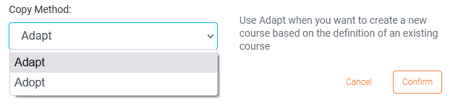

Once you confirm an adopt/adapt action, a new workflow is created in the designated college instance with you as the author. To continue editing it, log into that college instance and find the workflow in your “Inbox.” Thereafter, the proposal will behave as if you had used the “Create” a course option, and the workflow will follow that college’s review sequence.

# Flag/Resolve Flag Actions (Curriculum Committee Chairs only)

When college Curriculum Committee Chairs or the DCC Chair log in, all of the above features remain intact, but additional features are available.

When viewing an outline in a Dashboard workflow, an additional set of buttons is available: “Flag” or “Resolve Flag.” Flagging a workflow has the effect of preventing it from moving from the Dashboard to the Library until the DCC has had the opportunity to review it. This is intended to enable any challenge process permitted under AP 4022/4023. Note: Once flagged, the course is still “in review,” and thus the sunlighting clock continues to run. Resolving a flag removes the flag, enabling the workflow to move to the Library upon completing of the sunlight period, or immediately if that period has already passed.



When the “Flag” button is clicked, the following window is displayed. A rationale must be entered before the flag can take effect. This rationale should explain what elements of the proposal are being challenged and why, preferably with the names and contact information of the challengers so that the proposal author may address their concerns directly as quickly as possible.

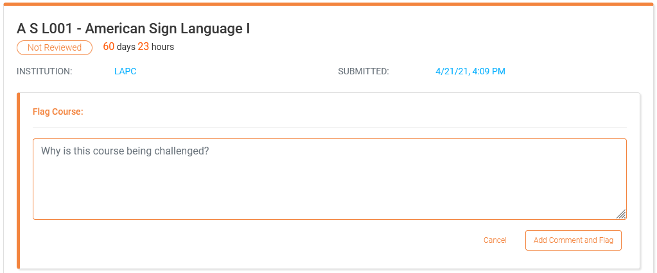

Once flagged, the workflow status will appear as “flagged” in the Dashboard and anyone logged in will be able to see the rationale. The user who flags a course also has the ability to remove the flag at any time by clicking the “Resolve Flag” button.

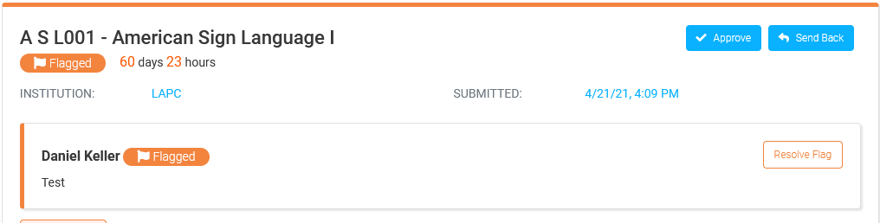

**A bit of advice**: Before flagging a workflow, encourage faculty to communicate directly with the authors of any workflow they wish to “challenge.” This gives the authors the opportunity to further explain their rationale, which might lead to a withdrawal of the challenge request. Or it might lead to the author withdrawing the proposal in order to address the challenger’s concerns. In other words, when the opportunity exists to engage in collegial communication that could avoid escalating an issue to a district-wide dispute, take it.

However, when there is not sufficient time left in the sunlighting period to enable a thorough discussion, it might be best to flag the proposal. This will provide enough time for the parties involved to work the issue out *without DCC intervention*, at which point the flag may be removed using the “unflag" button. If they can’t resolve it, then the DCC will do so for them.

# Send to Library/Send Back (DCC Chair only)

When a flagged workflow has been reviewed by the DCC, the DCC Chair may use the “Send to Library” or “Send Back” buttons to enact the result. If the DCC denies the challenge, then the DCC Chair will click “Send to Library.” If the challenge is upheld, the chair would click “Send Back.” Note: In the following image, “Sent to Library” shows as “Approve.” This is from a test site and will be updated soon.

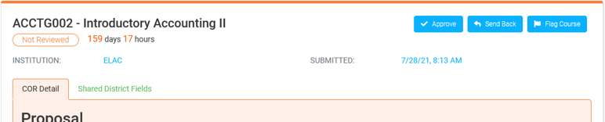

If sent back, the DCC Chair must also add a rationale. This should include reasons why the challenge was upheld. Or it might provide conditions under which the workflow may be resubmitted, if revised, such as fields that must be updated in order for it to be send forward.

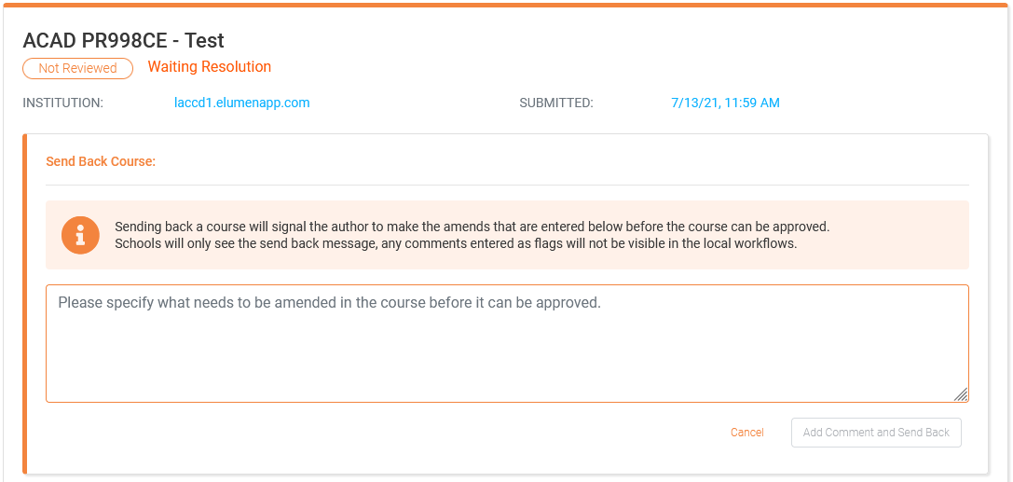

When a workflow is sent back under these circumstances, and the author updates the workflow per the rationale, it enters a special workflow at the author’s college. Depending on how the college wishes to deal with this situation, changes made in such a workflow might follow a shorter college approval sequence than a normal revision or they may follow the normal revision workflow sequence.

Once such a workflow leaves the college, it goes back to the DCC Chair who will check to see that the required conditions were met. If so, it will be sent to the Library. If not, it will be sent back again.

# Administrative User Actions (DCC Chair and EPIE/IT designees)

The Dashboard enables processes required by administrative procedures (such as AP 4022/4023). In order to keep in step with those procedures, users logged in as the DCC Chair or as designees from EPIE and district IT can use features in the “Configuration” page to customize the following.

* Designate which workflow types are posted for “sunlighting.”
* Specify how long the sunlighting period lasts and what non-duty days to “skip.”
* Specify what happens after the sunlighting period has elapsed.

In the example below, workflows would enter sunlighting if 1) the “trigger” workflow type equals “creation” (aka, “create a new course”) and the object type is “course” (as opposed to “program”), or 2) when the trigger condition “shared district field” “changes,” or 3) when the trigger indicates that any workflow for a “district course” does “not exist” at the proposing college, or 4) if the trigger indicates that the proposal includes a request to change cross-listing status. All of these conditions can be customized.

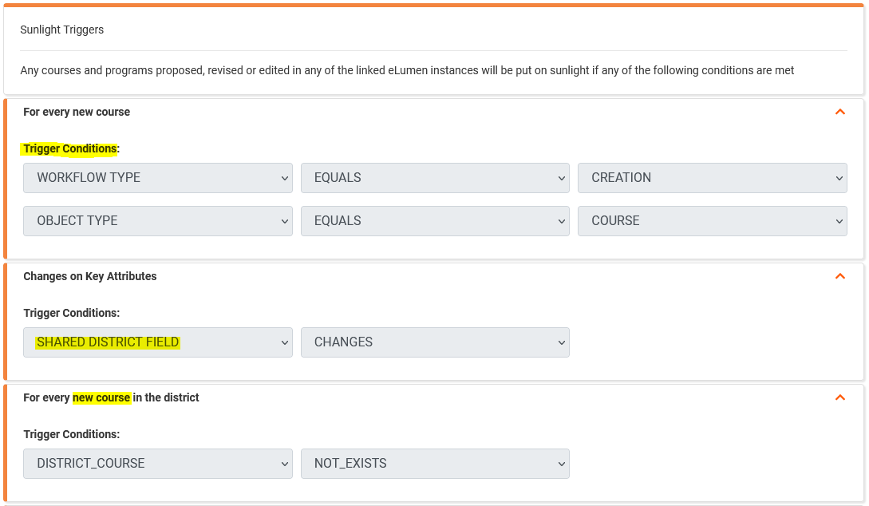

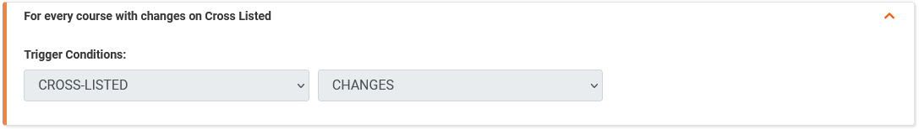

Once a workflow is in the sunlight period, the number of days required at that stage can also be customized. This is accomplished by setting a combination of the calendar days that must elapse, plus identifying “Non Working Days” that occur in any sunlight period so that they can be “skipped.” For example, a typical fourteen calendar day period includes ten work days. However, if that period included two Thanksgiving holidays (11/25 and 11/26), for example, the number of calendar days would be extended by two in order to ensure that ten work days had elapsed. In other words, the holidays are “skipped” or not counted in the required fourteen calendar days, so that in reality it would become sixteen calendar days.

The image below shows the non-duty days during the 2021-2022 academic year. But in a typical year, it would also include all summer days that are outside the faculty duty days. Thus, sunlighting periods overlapping summer would be extended by the entire summer’s worth of days, finishing up once the fall duty days resumed.

Lastly, the action that occurs once sunlighting has elapsed can be customized. Currently, according to AP 4022, if a course completes its sunlight period without being flagged for DCC review (i.e., without being challenged), it moves automatically to the Library. Other options shown could also be set, if that procedure were to change.

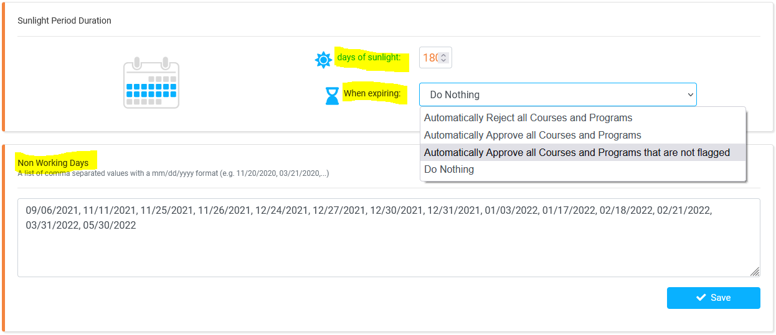

For a diagram of the complete workflow between college instance and district systems, see Appendix B.

# Appendix A: Course Outline of Record (COR) Template

[Return to the COR description earlier in this document.]

**Course Outline**

College College

Subject Abbreviation (CB01A) SUBJ

Number and Suffix (CB01B) ###X [include leading zeros]

Title (CB02) Title

Board Approval Date MM/DD/YYYY

Last College Approval Date MM/DD/YYYY

Effective Term Term YYYY

Honors Sections are Permitted Yes/No

**Hours Per Term (Min-Max)** Instruction/Contact Hours

Lecture (1:2) ##.##-##.##

Lab/Activity Type 1 (2:1) ##.##-##.##

Lab/Activity Type 2 (3:0) ##.##-##.##

Total ##.##-##.##

Out-of-class Hours – Total ##.##-##.##

Cooperative Education – Unpaid Hours ##.##-##.##

Cooperative Education – Paid Hours ##.##-##.##

To Be Arranged (TBA) Hours ##.##-##.##

**Units**

Unit Calculation Method* Standard/Coop Ed/Clock-hour/Noncredit

Minimum Units (CB07) #.##

Maximum Units (CB06) #.##

**Conditions on Enrollment (Requisites and Advisories)**

Prerequisite Course(s) List or N/A

Corequisite Course(s) List or N/A

Advisory Course(s) List or N/A

Other (Non-course) List or N/A

**Catalog Description**

Sample catalog description.

**Objectives**

1. List

**Content**

1. Outline

**Lab Content** (if applicable)

1. Outline

**Texts/Other Content Resources**

* Title, Author, Publication Date

**Methods of Instruction**

* List

**Assignment Types**

Reading List

Writing List

Out-of-class List

Fieldtrips/Other Activities, if applicable List or N/A

TBA Activities, if applicable List or N/A

**Methods of Evaluation**

* List

**Coding**

CB00 – Control Number CCC000000000

CB01A – Dept. No. (Subject Abbreviation) SUBJ

CB01B – Number (and Suffix) ###X [include leading zeros]

CB02 – Title Title

CB03 – TOP Code ####.##

CB04 – Credit Status X – Description

CB05 – Transfer Status X – Description

CB06 – Maximum Units #.##

CB07 – Minimum Units #.##

CB08 – Basic Skills Status X – Description

CB09 – SAM Code X – Description

CB10 – Cooperative Education Status X – Description

CB11 – Noncredit Classification (CDCP) X – Description

CB21 – Prior-to-college Status X – Description

CB22 – Noncredit Category X – Description

CB23 – Funding Agency Category X – Description

CB24 – Program Status X – Description

CB25 – General Education Status X – Description

CB26 – Support Course Status X – Description

Special Characteristics Code List or N/A

*Unit Calculation Methods:

* STANDARD: Total student learning hours (contact hours plus out-of-class hours) divided by 54 and rounded down to the nearest half-unit. One unit equals 1 hour lecture + 2 hours out-of-class, or 2 hours lab/activity (type 1) + 1 hour out-of-class, or 3 hours lab/activity (type 2).
* COOP ED: The sum of the total unpaid hours divided by 60 and/or total paid hours divided by 75, per CCR 55253.5 and 55256.6.
* CLOCK-HOUR: Same as above, but using a unit divisor of 37.5, per 34 CFR 600.2.
* NONCREDIT: 0.00 units.

# Appendix B: Workflow

